Documentation of Refining in MiniCAM
Page Kyle
September 23, 2008

[Monday, October 06, 2008: This doesn’t contain the most up-to-date sectoral representation of refining—oil refining for electric power sector is now its own supplysector, and it doesn’t consume electricity. This changes some of the calibration calculations but otherwise all is as written here.]

A number of changes related to the representation of refining in MiniCAM were made in September 2008. In addition to changes within the refining sectors themselves, there were also adjustments necessary in industry (particularly related to base year calibration), primary fuel CO2 coefficients, and resource extraction costs. This document traces steps that were made, lists all data sources used, and presents output from the model with and without a carbon emissions policy.

Motivation and Summary of Method
The primary motivation was to get the refining energy use out of industry and into refining. The CCTP FY08 made some headway in this regard, but it neglected the multiple inputs to individual refining technologies, and, while consistent, was incorrect in its depictions of the actual energy consumption of the refining sectors. In brief summary (documentation is with the CCTP FY08 workspace), the energy requirement of crude oil refining was estimated, and a consequent efficiency in the conversion from crude oil to refined liquids was calculated (about 94%). The efficiency in the model was left at 100%, and all other (non-crude) refining technologies were adjusted upwards by 6% to account for the energy that is assumed to remain accounted for in the industrial sector.

A separate approach has been used that explicitly accounts for all energy used and produced by all refining technologies. This allows analysis of the energy (as well as emissions) implications of deployment of unconventional refining technologies. From assumed refining energy intensities (units of crude oil, natural gas, and electricity consumed per unit of fuel output), the energy consumed by the refining sector in each region is calculated, and deducted from the previous estimate of industrial energy consumption.

Carbon capture and storage technologies are allowed, though at present the only ones in the model are coal-to-liquids Phases 1 and 2. Several fuels have multiple “phases” of CCS, as there are different streams of CO2 produced in the refining process, with different costs of capture. Non-energy costs are derived as the residual of assumed total (“well-to-wheel”) costs minus all known costs for each technology that are accounted elsewhere in the model (fuel extraction, regional cost adders, energy inputs, and delivery). An adjustment to the resource curves for shale oil was made, as the previous version included costs such as electricity consumption that are now explicit. The resource curves themselves are probably an area that merits further attention; I do not know exactly what costs are embodied in them. Finally, the CO2 coefficient of shale oil was also changed, again because the energy requirements of shale oil refining are now explicitly in the model. It is still higher than crude oil, to account for the CO2 released from cleaning natural gas released at the site of the shale oil extraction, but lower than it had been.

Energy Inputs and Outputs
All energy inputs and outputs are calculated in the Refining_tech_characteristics.xls workbook. Each technology has its own worksheet.
Crude oil refining: The IEA Detailed Energy Balances dataset was used for the US. All fuels produced by refineries were considered outputs, and the inputs were aggregated by fuel source (petroleum, natural gas, and electricity). Coefficients were calculated as follows for fuel i:
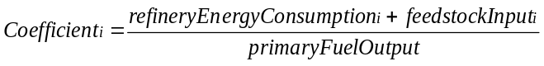
The resulting IO coefficients are as shown:
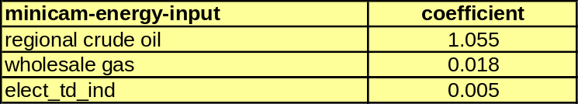

Shale oil refining: The shale oil refining technology modeled at present is representative of Shell’s in situ technology in development, and the technical parameters come from Dooley and Dahowski (2008). There is also a representative tar sands extraction technology, analagous to the Athabasca Tar Sands of Canada, based on data from the National Energy Board of Canada. However, this is not included in the model right now, as the same technology (the in site shale oil extraction) is assumed in all regions at present.

In summary, the energy requirements are assumed to be 275 kWh of electricity per barrel of shale oil produced, and in the extraction process, one third of the total energy released is in the form of natural gas. Refining of the resulting heavy crude into liquid fuels is assumed to have the same IO coefficients as regular crude oil refining in the US; the process takes some energy from the oil itself, as well as inputs of purchased natural gas and electricity.

The method for the representation of shale oil refining is detailed below; cost-related adjustments are detailed in the “costs” section of this documentation file.
- The “shale oil regional” supplysector is renamed “regional shale oil,” to be consistent with all other “regional” energy supplysectors
- The electricity required to extract the shale oil is assessed in the regional shale oil supplysector; the IO coef of “global shale oil” is 1, as no oil used in the extraction process, and the electricity coefficient is calculated as the electricity required to produce the shale oil. No other energy inputs are required.
- The primary fuel CO2 coefficient of shale oil is reset, to be equal to that of crude oil plus the CO2 released in cleaning the natural gas at the site of the extraction. Crude oil is 19.6 kg C / GJ; shale oil used to be 27 and now it is 21.1. It is lower because the 27 estimate was intended to implicitly include energy-related emissions from extraction; these emissions are now accounted explicitly (in the electricity sector). The only reason for increasing it at all is for future modeling of CCS—the CO2 from the gas cleaning process would be low-cost CCS material. Note: at present shale oil extraction and refining does not have a CCS option.
- The natural gas released is included as a secondary output of the shale oil extraction process, and is included in the regional shale oil supplysector. Note: secondary outputs are temporarily not included in the input files, only because the model sometimes has solution troubles and the secondary outputs probably don’t help with that.
The resulting IO coefficients for both processes are shown:
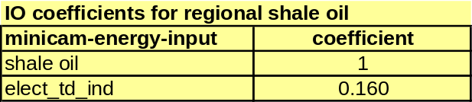
 (would be 0.5 if included)

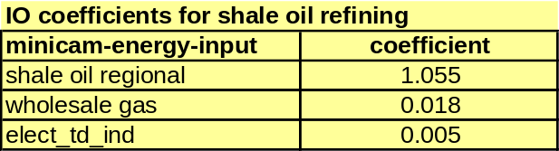

Coal to Liquids (CTL): The technology specifications are based on the plants in Dooley and Dahowski designed to produce 500k barrels a day. The energy balances are backed out from the carbon balances of the plant, using the assumed MiniCAM energy contents of the different fuels (coal = 27.3 kg C / GJ, and liquids = 19.6 kg C / GJ). While the plants produce both diesel and naphtha, it is assumed that the demand for naphtha is adequate such that it can be sold, and no further refining (e.g. into transportation fuels) is needed. The plants produce all requisite electricity from the coal, and do not produce excess electricity for sale to the grid. As well, no natural gas is needed in the process. Only one energy input is modeled, shown below:


Carbon capture and storage is also included as two technology options, detailed in the “Carbon Capture and Storage” section of this report.

Biomass Liquids: The technology modeled is a cellulosic ethanol conversion, based on the technological specifications outlined in Aden et al. (2002). In summary, the process consumes only corn stover as feedstock, and produces ethanol and some excess electricity. This electricity is included as a secondary output of the technology, though this may be a bit generous to assume that the technology is a net producer of electricity and also doesn’t consume gas or any other energy. However, it does consume a lot of biomass relative to the energy content of the resulting fuel, and there are a lot of CO2 emissions associated with the conversion. As with coal, there are two CCS technologies parameterized. Note: at present no CCS technologies are included for biomass liquids.

(would be 0.092 if included)

Gas to Liquids (GTL): The technology modeled is analagous to a proposed plant that Chevron is building in Nigeria (Chevron 2008). The plant produces all requisite electricity on-site, and does not sell any excess electricity to the grid. While at present, GTL is only practical in areas that have a lot of natural gas relative to the regional market demand, in the future it may be more important than we might otherwise think because of its relatively low carbon intensity. See the “Carbon Capture and Storage” section for a comparison with the other fuel refining technologies. On a related note, future users have to be careful with tech change in this technology. Because the input fuel (gas; 14.2 kg C / GJ) has a lower coefficient than the output fuel (liquids; 19.6 kg C / GJ), an IO coefficient less than 1.38 (=19.6/14.2) will actually result in a net-carbon-negative technology. This would make no sense; it would be purely an accounting mistake, but would be an easy one to make.

In any case, the IO coefficient is shown below:


Because of the low carbon intensity of the process, no CCS technologies are included at present. Any CCS technology would probably be costly, as the CO2 released in the GTL process is probably from combustion or diffuse sources.

Note also that this technology consumes regional natural gas, not wholesale gas—while the latter is the fuel consumed by the industrial/electricity sectors, it wouldn’t make sense here. Wholesale gas is only different from regional natural gas in that it allows the gas to be produced from coal or biomass feedstocks, but both of those are already explicit technologies in refining (coal -> gas -> liquids is the CTL technology, and biomass -> gas -> liquids makes no sense when biomass -> liquids is possible). Having that extra tangle of complication wouldn’t add anything in terms of real-world possibilities.

Base Year Calibration
Once the input/output coefficients are known for all refining technologies, the amount of energy that needs to be deducted from our current estimate of “industrial” (including refining) sector energy consumption can be calculated. For now, the same refining energy intensities are applied to all regions; the energy intensity of crude oil refining in the USA is assumed to apply everywhere. We do actually have data that would allow us to calculate region-specific refining intensities, but it was not deemed worthy of the time investment at present (the project for which this break-out has been done is US-focused). While that is on the to-do list for future work on refining, I don’t know how consistent the IEA’s data is across regions for non-OECD Petroleum Refinery energy use; what we might end up doing is picking a “representative” country in each region where the energy transformation sector data appears good, and using it as a proxy for all countries within the corresponding MiniCAM region. If we aggregate all countries by MiniCAM region, we risk treating partial observations (e.g. countries with the energy transformation row filled out but not the energy sector row, resulting in 100% efficiency) as complete observations, and getting distorted estimates of energy intensities.

The calculations actually end up having some complications, because of the nature of the exercise—we are deducting fuels (refined liquids, electricity, and gas) from the industrial sector, and the amount of refined liquids deducted feeds back into how much needs to be deducted. Therefore Algebra I is used. The worksheet ref_liquids_cal in the new calibration workbook walks through the calculations with explanations at each step, and the worksheet is probably more informative than the text that follows. The bottom line is that the energy flows balance, and the model calibration is no worse than it was before this break-out.

At present there are two refining sectors in MiniCAM: refined liquids enduse and refined liquids industrial. The enduse sector is simpler; the adjustment is as follows:
- All refined liquid fuel consumption in the buildings and transportation sectors (not including biofuel consumption) is aggregated, by region.
- This amount is used as the calibrated output of the “crude oil refining” technology of the “refined liquids enduse” sector.
- The inputs of regional crude oil, wholesale gas, and elect_td_ind are calculated as the respective IO coefficients times the calibrated output value.
- The output of refined liquids is subtracted from the input of regional crude oil, and this value is set aside, to be subtracted later from the estimate of industrial energy use. This value is equal to the output times the (crudeOilIOCoef – 1), and represents the energy-use fraction of the crude oil input to the refinery, which had previously been accounted as part of the industrial sector. The feedstock part had been in the refining sector to begin with, so it doesn’t get subtracted from industry.
The adjustment to refined liquids industrial is less straightforward; an equation is used to derive the correct amount of fuel output from the sector, and the consequent deduction from the industrial sector. The steps leading to that equation are shown below; note that “Liquids” refers to liquid fuel consumption of the relevant sector.

The above equations are combined to form:
Once the output from the refined liquids industrial sector is calculated, then one can determine the inputs of crude oil, gas, and electricity. The amounts of each fuel to subtract from the industrial sector are added to the corresponding fuels used to produce refined liquids enduse, and then deducted from industrial energy consumption in each region. This is done in the caldata workbook. The resulting estimates of industrial and electricity sector liquids consumption are checked against the output of refined liquids industrial to ensure that the flows are balanced. All is indeed peachy.

As a note to future developers: because of the order of read-in files from the CCSP to the CCTP FY08 base input file, the calibration input file “final_enduse_cal.xml” is partially over-written by a file in the cement folder, “industry_adj_for_cement.xml”. Basically, the cement files break cement out of industry, and as a result, there is a file to re-set the calibrated fuel inputs to the industrial sector in each region. If this file isn’t updated to the latest caldata file, any changes made in the caldata workbook itself won’t matter in a model run. So if any changes are made to the representation (e.g. IO coefs for other regions being changed) one should open up the cement workbook, link it to the caldata workbook, and remake the industry_adj_for_cement xml file. All should link through correctly. Also check to make sure there are no negative numbers in any of the industry/fuel combinations.

In the current exercise, the derived natural gas consumption by petroleum refineries in Korea in 1990 was greater than the previous estimate for the whole industrial and transformation sector; apparently there wasn’t a whole lot of natural gas use in Korea in 1990. In fact, petroleum refineries didn’t consume any (according to the IEA database). However, rather than adjust IO coefficients in this region alone, currently Korea’s industrial sector natural gas consumption is simply not adjusted for the derived refinery use; the result is that as a whole, the region’s gas consumption is high by 0.037 EJ. This will get corrected once we move to region-specific IO coefficients.

A Note on Regional Energy Intensities
One advantage to breaking out regional petroleum refining production technologies and energy intensities is that it might give us some basis for future improvement in petroleum refining. At present, we don’t have a good grasp on this industry, as it isn’t included in the IEA’s book on industrial energy efficiency. I’d imagine that there is some heterogeneity in production intensities by region, and we could have all regions tend to converge towards the most efficient production technologies currently in place. At present, the intensities are assumed to improve modestly for all fuels (0.05% per year), so that the crude oil IO coefficient never approaches 1.

Carbon Capture and Storage
At present, CCS is allowed in two phases for CTL; biomass would have the same technology set-up, and the calculations are already in place in the Refining_tech_characteristics.xls workbook that would allow CCS on shale oil refining, crude oil refining, and GTL. The backdrop for these technologies is the depiction of costs of CCS for CTL and shale oil refining in Dooley and Dahowski (2008). CTL costs are as follows in the paper:
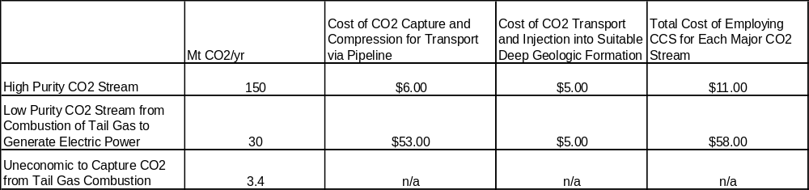

The costs are disaggregated to an intensity penalty and a non-energy-cost penalty for input to MiniCAM; this is based on a worksheet set up by Marshall Wise, based on a paper by Bob Williams. The important point is that the costs get assessed. Currently Phase I is assessed a 4% intensity penalty and a cost penalty of approximately 30%. Phase II gets a 10% efficiency penalty and a cost penalty of 49%. Note that the intensity penalty would apply to all energy inputs equally; e.g. for crude oil refining, it can’t only be applied to the electricity input. This is probably trivial.

Shale oil refining looks like this:
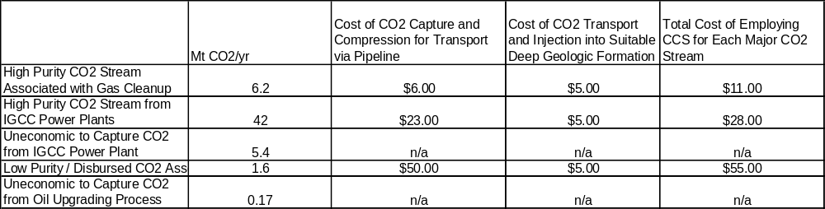

In summary, the low-cost emissions reductions would take place in the regional shale oil sector, as this is where the gas output and associated emissions are accounted for. The low-purity stream would be the only CCS technology allowed in the refining sector; it would be costly and wouldn’t reduce aggregate emissions by much. The same (latter) technology could be applied to crude oil refining and GTL.

Biomass liquids CCS technologies would have two phases, as for coal, with the magnitudes of the different streams based on Aden et al. The majority of the emissions are low-grade CO2 streams associated with stover combustion; these would get a higher price (around $55/t CO2). Emissions from the “Scrubber Vent” (about 25% of the total) would be able to be scrubbed at $6-12/t CO2. Note that this would be a net-carbon-negative technology, and could be quite cost-competitive in a policy scenario. Again, the calculations that would allow input to the model have already been made, even though it isn’t in the model at present.

A Note on Carbon Intensities
As a backdrop for future discussion of carbon capture and storage technologies in the refining sector, the gross and net carbon intensities of all technologies currently in the model are shown:

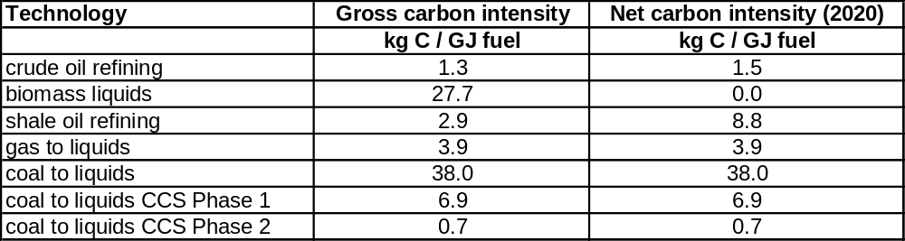

Note that this does not include the tailpipe emissions, assumed equal for the output of all technologies (19.6 kg C / GJ). Because biomass liquids are produced from a fuel whose production entails negative emissions, the “net” emissions from this technology are 0, as the process is assumed to not use any non-biomass fuels. Shale oil refining emissions increase substantially when the electricity-related emissions are considered, but it is still a good deal less than CTL.

However, note that the “net carbon intensity” is scenario-dependent (depending on the C intensity of electricity production), so the numbers should be interpreted with caution. Still the column gives an idea of the magnitude of the emissions from each technology, and the dynamics that will come into play in a policy scenario. The most noteworthy point is that even with CCS Phase 1, the gross carbon intensity of CTL is the highest of any technology shown. The higher “net” emissions of shale oil refining are from the electricity sector, and won’t apply to a policy scenario as electricity will be mostly de-carbonized. This point, that the sheer magnitude of the carbon intensity of CTL makes it carbon-intensive even with CCS, has been made before, but it’s a timeless gem.

Costs
The part that has ended up being the most work in this representation, and also the part most in need of attention going forward, is the cost assumptions. Previously our assumptions were “antediluvian” (M. Wise, pers. comm.); now there is some effort made to cross-check the estimates against expected costs of the different technologies for producing liquid fuels, but there are still several issues. The first is that we should all agree on how much we want the unconventional fuels to cost with respect to crude oil refining and with respect to each other, both in 2020 and in the long term, and the second is that the resource curves we’re using in MiniCAM probably need to be revisited. We need to get as much of the energy-related costs into the appropriate “regional” sectors as possible, which will involve adjusting the resource costs downward. More on that in the “future directions” section.

In any case, the non-energy costs of the different refining technologies input to MiniCAM are generally residuals; the real assumptions being made are the total costs of refined liquid fuels produced by the different technology pathways. The total production cost of refined liquids produced by crude oil refining (in the refined liquids industrial sector—without the added “delivery” charge applied in the enduse sector) is assumed to be $1.25 per gallon. Note: this assumption is not crucial for anything. It can easily be changed and will influence the n-e-cost : fuel cost ratio, but not by much within reasonable limits. The non-energy cost is calculated as this total cost minus any fuel costs at the refinery (prices of regional crude oil, electricity, and natural gas, multiplied by their respective IO coefficients). Non-energy costs and total fuel costs are compared to costs of crude oil for reference. Fuel costs used in the calculations are from model output in 2005 and 2020; while this sets up a somewhat recursive process (having to do model runs to generate input files sets up a never-ending process), for the most part costs of globally traded fuels in 2005 and 2020 shouldn’t change a whole lot between different scenario runs.

Biomass liquids costs are based on the $1.07 per gallon of ethanol that is the target of the refinery in Aden et al (2002). While this might seem a bit aggressive, the low energy content of ethanol (75700 BTU/gal, compared to about 137,000 for diesel) actually makes the technology pretty expensive. Non-energy costs are backed out from this using MiniCAM biomass prices and the IO coefficient. Biomass liquids costs are 53% higher than crude oil refining (the highest of any unconventional fuels).

Coal to liquids non-energy costs are based on the comparison to crude oil refining in Kurevija et al (2007); this paper presents the cost of a gallon of diesel for CTL, GTL, and crude oil refining, broken down into component parts. While the assumptions for input fuel requirements and costs aren’t necessarily consistent between this paper and the present representation, they nevertheless give a rough estimate of how much more expensive we expect CTL and GTL to be, compared to crude oil refining. The CTL costs are cross-checked with the Task Force on Strategic Unconventional Fuels report (2006); the comparison isn’t direct, as the latter focused on producing syncrude from coal, not diesel. Therefore the anticipated costs (~$40/barrel of syncrude) are a bit lower than the costs in the model right now (~$70/ barrel of diesel). CTL costs are 14% higher than crude oil refining.

Gas to liquids costs are parameterized in similar fashion to CTL; they are assumed to be 20% higher than crude oil refining. While the non-energy costs are lower, the fuel costs are higher.

Shale oil refining costs are based loosely on the CTL costs, and are a little bit higher in deference to the Task Force on Strategic Unconventional Fuels report (2006). This report presented ranges of both CTL and shale oil refining, and while there was considerable overlap in the ranges presented, the shale oil cost estimates were generally higher than those for CTL. Costs are assumed to be 20% higher than crude oil refining, though the costs drop more in the future than CTL costs, and the technology is cheaper than CTL in the last two time periods.

A note on Shale Oil Refining Costs
In order to make the shale oil refining costs reasonable (i.e. non-negative non-energy costs), the supply curves for the resource in each region were adjusted downward by $2 1975$/GJ in for each point. The lowest point on the supply curves had been 3.8, which is approximately what the cost ought to be in 2020 to be 20% higher than crude oil refining. Because there is also an electricity cost, plus the shale oil consumed in the refinery, the derived cost floor (if refinery n-e costs were 0) using the old supply curve ends up being about $5/GJ. This decreases over time, due to the assumed 1%/yr techChange on the shale oil resource. But it’s still probably higher than we want in the early time periods.

The electricity-only cost of shale oil extraction was calculated to be about $1.1/GJ (1975$), but even this was inadequate to drop the costs enough to get reasonable non-energy refining costs. $2 was chosen so that the n-e cost of the shale oil refinery would be comparable to that of a crude oil refinery (the two should be equivalent in the given representation—the shale oil produced by the regional shale oil supplysector is assumed functionally equivalent to regional crude oil). The future techChange was lowered to 0.5% per year so that the decrease in costs wouldn’t be as sharp, and so that the costs starting in 2020 could be approximately what DOE is forecasting.

Below are graphs of the technology prices of each refining technology, with and without a policy:

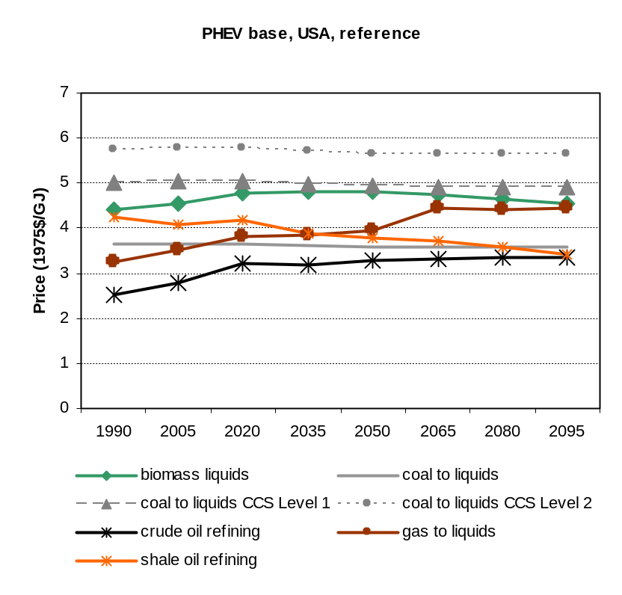
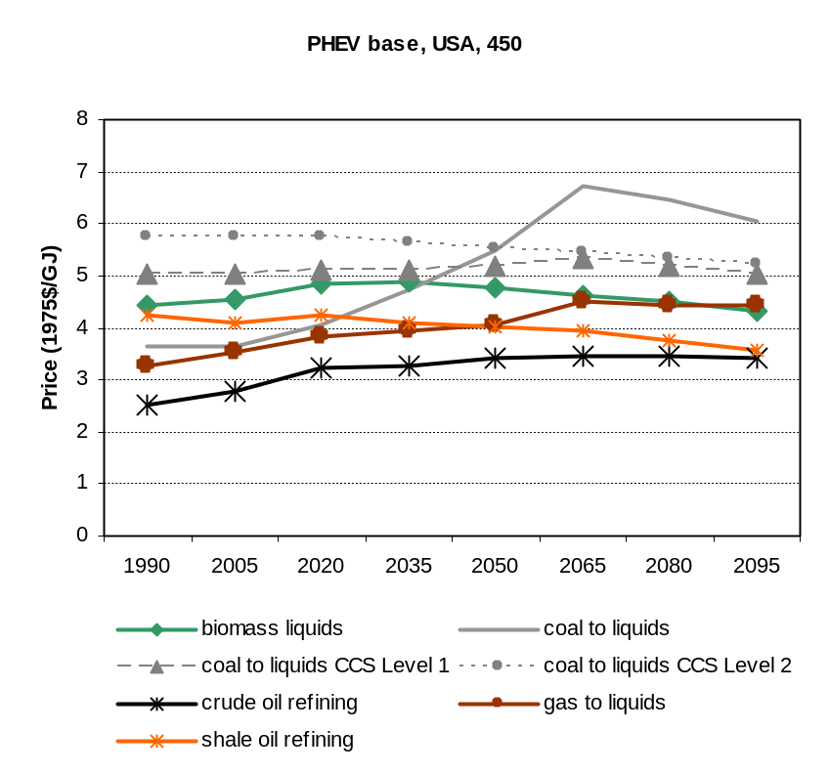
As shown, in both scenarios, crude oil refining increases in price modestly, and remains the cheapest technology through 2095; this is the result of a number of factors. Briefly, the non-crude technologies are logited in, perhaps representative of regional and national energy security prioritization. The use of the non-conventional liquid fuel resources starting in 2020 keeps crude oil production from climbing the resource supply curve, so we don’t get the 2095 kink anymore (when crude oil production crashes in 2095 due to passing a certain threshold on the global supply curve). On a related note, the logit exponents we choose for the refining subsector sharing are pretty important for the output. The shareweights aren’t a big part of the scenario for now; in the base years, they are selected so that the output of unconventional fuels in the US generally corroborates the Annual Energy Outlook (2008) estimates. Note: this fine-tuning hasn’t been done yet. Sharewts are 0.1 in 2020, and 1 in 2035 in the scenarios shown below. The same shareweights are used for all regions, representative of the fact that some of these technologies aren’t yet ready for large-scale deployment. All technologies are allowed to compete purely on the basis of assumed economics starting in 2050.

With a policy, notice that the only refining technology to become uncompetitive is CTL, and the resulting effects on the non-CTL technologies are not sufficient to make CTL_CCS competitive. This is because shale oil emissions are mostly electricity-related, and CCS at electric power plants largely removes the emissions from shale oil extraction. Biomass liquids emissions aren’t taxed, as the emissions are from a fuel that receives carbon credits at the point of production. GTL, crude oil refining, and shale oil refining don’t become much more expensive because the net carbon intensities aren’t very high (all are lower than CCS Phase 1; see table in CCS section).

Output
Fuel production and direct (non-electricity) emissions from the different technologies are shown for a reference and a 450 stabilization policy:
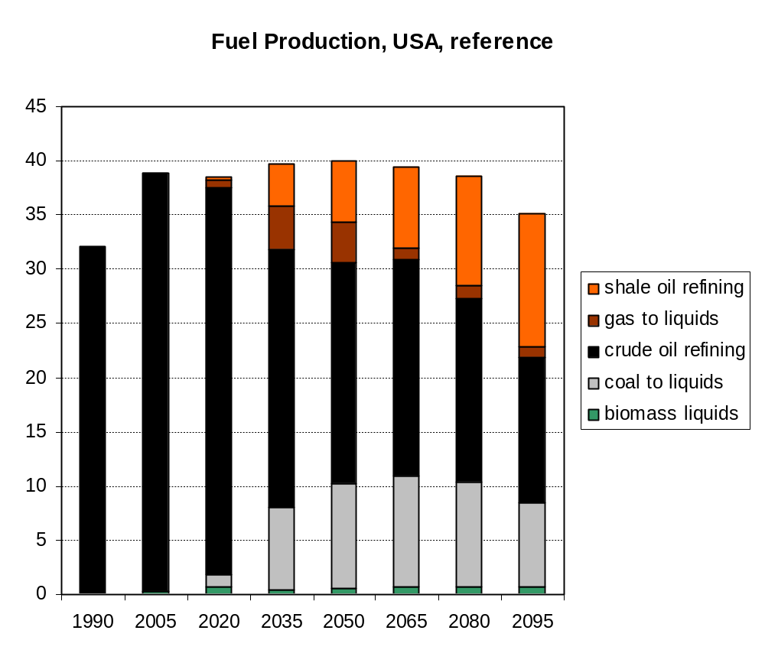

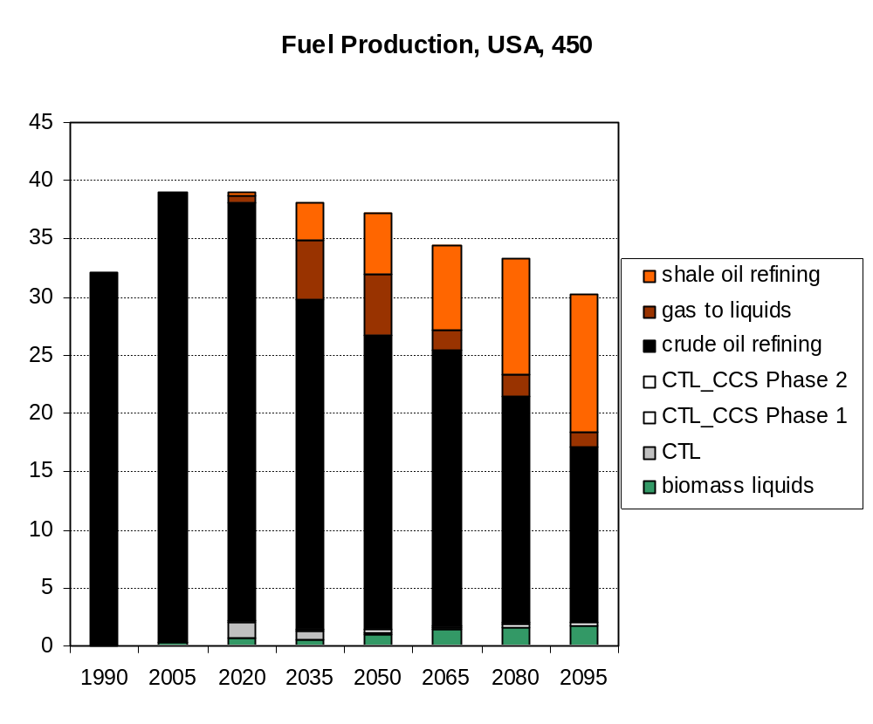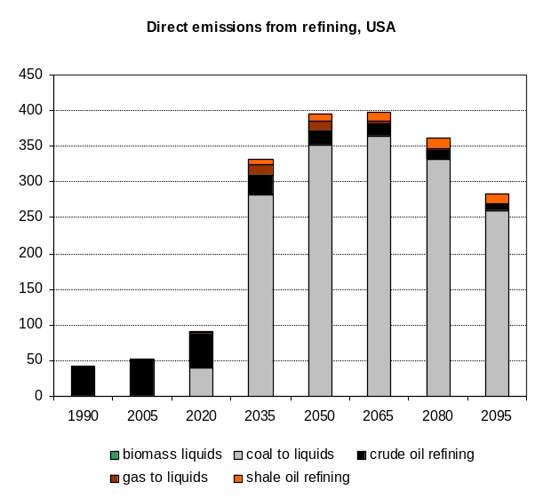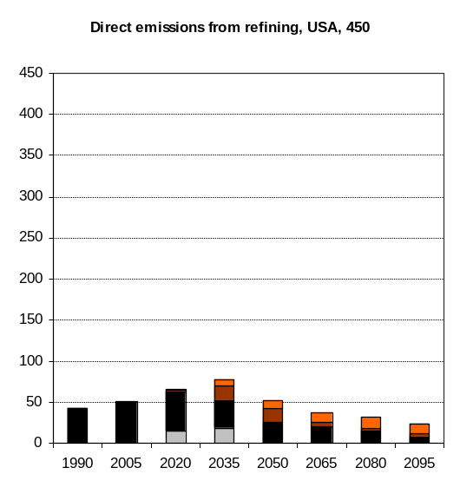

In summary, the fuel production in the US doesn’t change a whole lot in response to a C policy, as the technology options at the end-use side are limited. However, the feedstocks do change as before to reduce the carbon intensity of the refining sector. Coal-to-liquids is basically shut off, even when carbon prices aren’t that high; it is replaced mostly by biomass liquids and crude oil. Shale oil and GTL respond in similar fashion to the policy: they take some of the share vacated by CTL, but don’t show any dramatic response.

The biomass emissions have been deleted from the emissions graphs above, as biomass emissions are considered to be carbon-neutral on the whole. Note that the graphs above do not show the electricity-related emissions from the refining sector; this really only applied to shale oil refining, but would have the effect of increasing the shale oil emissions in the reference case. The policy case would be similar to what it is in the graph above.

As a brief reaction, these graphs mostly differ from our previous projections in the shares of non-crude fuel production. These scenario do not differ from the current mainline reference case in the ratio of unconventional fuels to crude oil refining; they differ in the ratios of the different “unconventional” technologies. Shale oil refining had been dominant, accounting for between 70% and 90% of the total unconventional oil production in all future time periods. Now, we see some more divergence; this is probably more accurate, as the cost projections for shale oil refining are more expensive, not less expensive, than crude oil. Moreover, the literature on the different technologies don’t show all that much heterogeneity between technologies (though a good deal of heterogeneity within technologies).

As well, this new representation gives shale oil a good deal more flexibility: instead of having a fixed carbon intensity of 27, the total (net) C intensity of this pathway through to the end-user will be anywhere between 21.1 kg C / GJ and 30 kg C / GJ (with no upper limit), depending on the carbon intensity of the electric sector. CTL is likewise given a flexible C intensity (though CCS), and in fact by allowing CCS technologies all of the technologies could be given C intensities that are responsive to a policy.

Future Directions
Now that our model can handle multiple inputs, we should handle energy extraction energy requirements in the relevant “regional” fuel sectors. For example, put coal mining energy use in the regional coal sector. While having it in the industrial sector is okay for base year energy accounting (all energy is accounted for somewhere), it doesn’t allow us to model the implications of the different fuel types going forward. Probably not such an issue for coal and gas, but for shale oil and tar sands, which will use tremendous amounts of electricity and/or gas, we’ll want to explicitly represent these energy requirements. And while we’re explicitly representing those, we can’t be letting coal get away for free. One can of worms leads to another one.

The supply curves: the big MiniCAM documentation file makes mention of them, and what they stand for, but doesn’t explicitly address each supply curve for the resources available in each region. If they’re based on DOE studies, we maybe ought to update them to more recent estimates of reserves, and if they’re internally calculated, it would be good to break them out and see what costs exactly are included in their derivation. Energy-related costs are probably a big part of the curves, and this step of deducting an estimated amount from the existing supply curves, while necessary in this project, should not be seen as a long-term solution for future model development.

Also, getting the appropriate refining energy intensities might be a good exercise for a new employee—lots of practice with the IEA energy balances, learning the meaning of an IO coefficient, and following an established routine for the calculations that’s already set up. Plus, the added advantage that what we’ve got in the mean while is a model that’s up and running, and the changes in the IO coefficients probably won’t change the output in a noticeable fashion. Just some more cinderblocks in the foundation.

References
Aden, A., M. Ruth, K. Ibsen, J. Jechura, K. Neeves, J. Sheehan, and B. Wallace. 2002. Lignocellulosic Biomass to Ethanol Process Design and Economics Utilizing Co-Current Dilute Acid Prehydrolysis and Enzymatic Hydrolysis for Corn Stover. National Renewable Energy Laboratory. NREL/TP-510-32438.

Canada National Energy Board. 2008. Opportunities and Challenges to 2015: An Update Questions and Answers. Available at: http://www.neb.gc.ca/clf-nsi/rnrgynfmtn/nrgyrprt/lsnd/pprtntsndchllngs20152006/qapprtntsndchllngs20152006-eng.html. Retrieved September 25, 2008.

Chevron. 2008. Gas-to-Liquids. Available at: http://www.chevron.com/deliveringenergy/gastoliquids/. Retrieved September 25, 2008.

Dooley and Dahowski. 2008. Large Scale U.S. Unconventional Fuels Production and the Role of Carbon Dioxide Capture and Storage Technologies in Reducing Their Greenhouse Gas Emissions. Energy Procedia. In Review.

Kurevija, T., N. Kukulj, and D. Rajkovic. 2007. Global prospects of synthetic diesel fuel produced from hydrocarbon resources in oil and gas exporting countries. Rudarsko-geološko-naftni zbornik Vol. 19 str. 79 – 86.

Task Force on Strategic Unconventional Fuels. 2007. America’s Strategic Unconventional Fuels. Volume III: Resource and Technology Profiles.

